Recursive Resolver
# Source: Chatgpt (GPT-5-Mini) at [1/18/2026]
A Recursive Resolver (also called a DNS Resolver) is a DNS server that receives your DNS query (like www.google.com) and does all the work of finding the answer for you — by querying other DNS servers on your behalf.
📡 It's the first DNS server your computer contacts when you open a website.

🧠 Example: You Type www.example.com
# Source: Chatgpt (GPT-5-Mini) at [1/18/2026]
- Your device asks the recursive resolver for the IP of www.example.com.
- The resolver checks its cache:
  - ✅ If it has the answer → it returns it immediately.
  - ❌ If not → it contacts other servers step-by-step:
    - 🌍 Root DNS server
    - 🔠 TLD server (e.g., .com)
    - 🏁 Authoritative DNS server (for example.com)
- The resolver gets the IP address and returns it to your device.

🧭 Visual Overview
# Source: Chatgpt (GPT-5-Mini) at [1/18/2026]
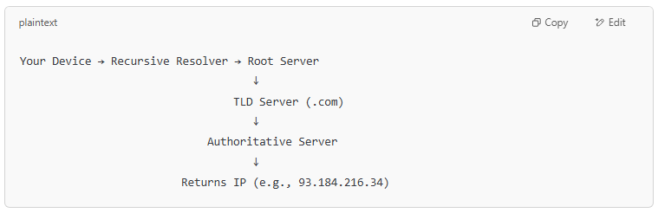
Your Device → Recursive Resolver → Root Server
↓
TLD Server (.com)
↓
Authoritative Server
↓
Returns IP (e.g., 93.184.216.34)

🔐 Recursive Resolver Features
# Source: Chatgpt (GPT-5-Mini) at [1/18/2026]
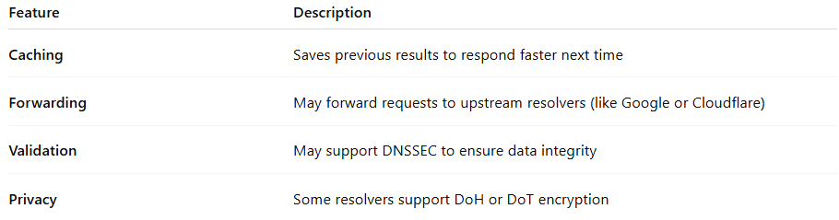

Feature | Description
Caching | Saves previous results to respond faster next time
Forwarding | May forward requests to upstream resolvers (like Google or Cloudflare)
Validation | May support DNSSEC to ensure data integrity
Privacy | Some resolvers support DoH or DoT encryption

🧰 Examples of Public Recursive Resolvers
# Source: Chatgpt (GPT-5-Mini) at [1/18/2026]
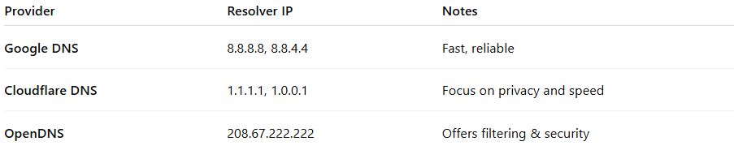

Provider | Resolver IP | Notes
Google DNS | 8.8.8.8, 8.8.4.4 | Fast, reliable
Cloudflare DNS | 1.1.1.1, 1.0.0.1 | Focus on privacy and speed
OpenDNS | 208.67.222.222 | Offers filtering & security

✅ Summary
# Source: Chatgpt (GPT-5-Mini) at [1/18/2026]

Recursive Resolver = Your DNS middleman
🔍 Takes your query and finds the answer
🧠 Uses cache + root + TLD + authoritative servers
🚀 Makes DNS look simple and fast for users

